**MEE 3506** **FLUIDS LABORATORY**

**AIRFOIL DRAG AND LIFT FORCES IN A WIND TUNNEL**

1. **OBJECTIVES:**
2. Measure the pressure distribution and the drag & lift forces on an airfoil in a wind tunnel.
3. Determine the drag and lift coefficients for flow over an airfoil.
4. Study the effect of angle of attack on pressure distribution, drag, and lift.
5. **THEORY:**

Figure 1 illustrates the surface forces, **F**, caused by pressures and shear stresses, **τ**, on an object immersed in a viscous fluid.

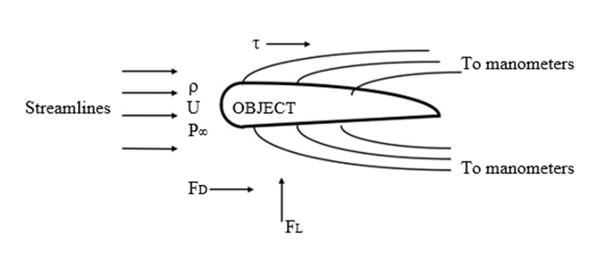

**Figure 1**: An Object in a Viscous Flow Stream.

The net force, **FN,** on the object, can be resolved into two components:

* Drag Force, **FD,** is the force parallel to the flow vector
* Lift Force, **FL**, is the force normal to the flow vector

The drag and lift coefficients, **CD** and **CL** are defined as:

|  |  |
| --- | --- |
| $$C_{D}=\frac{F_{D}}{\frac{1}{2}ρAV^{2}}$$ | (1) |
| $$C_{L}=\frac{F_{L}}{\frac{1}{2}ρ{AV}^{2}}$$ | (2) |

Where *ρ* is the fluid density, *V* is the freestream velocity, and *A* is the characteristic area of the object. For airfoils *A=b*c* where *b* is the span, and *c* is the chord length. For the airfoil considered in the experiment, the span is 12in, the chord length is 6 in, and the thickness is 0.72 in.

From the Buckingham PI Theorem, the drag and lift forces on a cylinder as well as an airfoil can be expressed in terms of dimensionless parameters controlling the flow.

|  |  |  |
| --- | --- | --- |
| For an airfoil: | ***CD = CD (Re, , b/c)*** | (3) |
|  | ***CL = CL (Re, , b/c)*** | (4) |

The lift and drag forces can be determined by integrating the surface forces using a differential analysis of the fluid flow. In this lab, we will experimentally determine the lift and drag forces and then compare the experimental results with the published results.

For an open-circuit wind tunnel, the total pressure is equal to the atmospheric pressure, thus in terms of gauge readings, the total pressure is zero. Therefore

$$\begin{aligned}P_{T}=P_{s}+P_{D}=0 \#\left(5\right)\end{aligned}$$

Where *PT* is the total pressure, *P­s­* is the static pressure, and *PD* is the dynamic pressure. By recording the static pressure, the velocity in the wind tunnel can be determined

$$\begin{aligned}P_{s}=-P_{D}=-\frac{1}{2}ρV^{2} \#\left(6\right)\end{aligned}$$

**III. EXPERIMENTAL APPARATUS AND PROCEDURE**

**Experimental Apparatus:**

1. Plint Suction Tunnel TE 54/D (Fig. 2)
2. Plint electronic three-component force balance
3. Dwyer pitot-static tube system
4. An airfoil

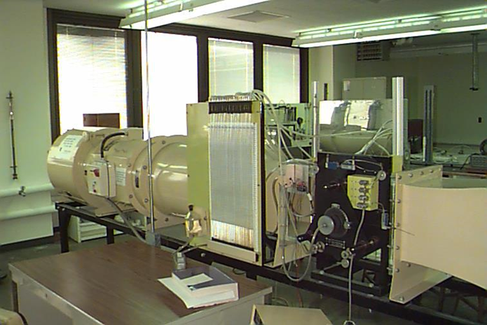

**Figure 2. Plint Suction Tunnel TE 54/D**

**IV. DATA ANALYSIS**

Experimental Procedure

1. Record the room temperature and pressure
2. Turn on the electronic three-component force balance
3. Unscrew the locks from the balance and ensure that it is freely hanging for accurate results. During the experiment make sure that the locks do not vibrate back into place!
4. Zero the angle of attack of the airfoil
5. Set the speed to setting 5 on the scale
6. Record the lift and drag forces once every 2 seconds, 20 total data points
7. Record the heights of ALL 24 manometers. Pressure measurements must be taken from a level viewing point. (Note that manometer 23 is the static pressure and manometer 24 is the total pressure. Note that negative pressures on the airfoil increase the heights of the manometers while pressures greater than atmospheric decrease its height.)
8. Change the angle of attack to 2 degrees (the airfoil will point downward) and repeat steps 6 and 7
9. Repeat steps 6 and 7 for angles of 2, 4, 8, 10, 12, 14, 16, 18, 20, 22, and 24
10. Repeat for a speed setting of 2.5
11. Using the provided FLUENT files numerically model the airfoil from the wind tunnel for both speeds and all angles of attack and compare the predicted lift and drag coefficients and pressure distributions to those experimentally determined.
    1. Note the laminar model will fail at high angles of attack

Your experimental report must include:

1. The pressure distribution, and lift and drag coefficients for all angles of attack
2. You must note the difference in the angle between the dial and DAQ to ensure you are accurately recording the angle of attack

**V. Results and Discussion**

1. How does the lift coefficient vary with angle of attack?
2. How does the drag coefficient vary with angle of attack?
3. Determine the ratio of the lift and drag coefficients (CL/Cd) for the various angles of attack and compare it to published data for a NACA 0012 airfoil (airfoiltools.com)
4. Compare the lift coefficient to the drag coefficient.
5. How does speed affect the lift and drag coefficients?
6. Compare the pressure distribution of the airfoil for low and high speeds.
7. Determine your stall angle.

**References**

1. B.R. Munson, D.F. Young, T.H. Okiishi, Fundamentals of Fluid Mechanics, 5th Edition, John Wiley & Sons, 2006, ISBN 978-0-471-67582-2.
2. M.J. Moran, H.N. Shapiro, Fundamentals of Engineering Thermodynamics, 6th Edition, John Wiley & Sons, 22008, ISBN 978-0-471-78735-8.
3. T. G. Beckwith, R. D. Marangoni, J. H. Lienhard V, Mechanical Measurements, 6th Edition, Pearson Education, 2007, ISBN 0-201-84765-5.
4. J.P. Holman, Experimental Methods for Engineering, 7th Edition, McGrew-Hill, 2001, ISBN 0-07-366055-8.